**Study to support the Evaluation of the EU Adaptation Strategy**

**Open public consultation Factual Summary Report**

|  |  |
| --- | --- |
|  | |
|  | |

Richard Smithers, Ruth Phillips-Itty (Ricardo Energy & Environment),

Martin Nesbit, Andrea Illes (IEEP).

Laura Baroni, Lisa Eichler, Matthew Smith (Trinomics)



EUROPEAN COMMISSION

Directorate-General for Climate Action

Directorate A — International and Mainstreaming

Unit A3 — Adaptation

*Contact: Andras Toth*

*E-mail: Andras.Toth@ec.europa.eu*

*European Commission  
B-1049 Brussels*

Table of contents

A Table of contents i

1 Public consultation 1

1.1 Approach 1

1.2 Results 5

# Public consultation

Approach

### Target group

All citizens and organisations were welcome to participate. To avoid stakeholder fatigue, it was mentioned to stakeholders answering the targeted survey that there was no need to also reply to the consultation (since the targeted survey covered all aspects in more depth), although they could answer both if they wanted to.

### Timing

The public consultation was open for the mandatory duration of 12 weeks from December 7th 2017 up to March 1st 2018.

### Objective

The aim of the public consultation was to gather feedback from the general public regarding the EU’s Strategy on Adaptation to Climate Change. The objective as presented online is as follows:

|  |
| --- |
| The [EU Strategy on Adaptation to Climate Change](http://eur-lex.europa.eu/legal-content/EN/TXT/?uri=CELEX:52013DC0216) (from now on: the Strategy) adopted in April 2013 aims to increase the resilience of the EU territory by enhancing the preparedness and capacity of all government levels to respond to the impacts of climate change.  The Strategy commits to delivering three objectives - promoting action by Member States; ‘climate-proofing’ action at EU level; and better-informed decision-making - through the implementation of eight Actions:  **Action 1: Encourage all Member States to adopt comprehensive adaptation strategies:** This action involves the provision of guidelines by the European Commission to help Member States to develop, implement and review their adaptation policies, as well as the development of an adaptation preparedness scoreboard, identifying key indicators for measuring Member States’ climate readiness.  **Action 2: Provide LIFE funding to support capacity building and step up adaptation action in Europe (2014-2020):** The Commission will promote adaptation in vulnerable areas (cross-border management of floods; trans-boundary coastal management; mainstreaming adaptation in urban land use planning, building layouts and natural resources management; mountain and island areas; sustainable management of water; combating desertification and forest fires in drought prone areas). The Commission will also support the establishment of vulnerability assessments and adaptation strategies, including those with a cross-border nature, and promote awareness-raising on adaptation.  **Action 3: Introduce adaptation in the Covenant of Mayors framework (2013/2014):** The Commission will support adaptation in cities, in particular by launching an initiative, based on the model of the Covenant of Mayors, through which local authorities can make a voluntary commitment to adopt local adaptation strategies and awareness-raising activities.  **Action 4: Bridge the knowledge gap:** The Commission will work with Member States and stakeholders to identify adaptation knowledge gaps and the relevant tools and methodologies to address them, and feed the findings into the programming of Horizon 2020, the EU’s 2014-2020 framework programme for research and innovation. It will also address the need for better interfaces between science, policy making and business. The Commission will also promote EU-wide vulnerability assessments, support the Joint Research Centre in its work on estimating the implications of climate change, and undertake a comprehensive review of what global climate change will mean for the EU.  **Action 5: Further develop Climate-ADAPT as the ‘one-stop shop’ for adaptation information in Europe:** The Commission and the EEA will improve access to information and develop interaction between Climate-ADAPT and other relevant knowledge platforms, including national and local portals. Special attention will be given to cost-benefit assessments of policy and to innovative funding.  **Action 6: Facilitate the climate-proofing of the Common Agricultural Policy (CAP), the Cohesion Policy and the Common Fisheries Policy (CFP)**: The Commission provided guidance on how to further integrate adaptation under the CAP, Cohesion Policy and CFP. Member States and regions can also use funding under the 2014-2020 Cohesion Policy and CAP to address knowledge gaps, to invest in the necessary analyses, risk assessments and tools, and to build up capacities for adaptation.  **Action 7: Ensuring more resilient infrastructure:** This action includes launching a mandate for EU standardisation organisations to identify and revise industry-relevant standards in the area of energy, transport and buildings, to ensure better inclusion of adaptation considerations. Guidelines for project developers on climate-proofing vulnerable investments were provided with the Strategy. The Commission will also explore the need for additional guidance on mobilising ecosystem-based approaches to adaptation.  **Action 8: Promote insurance and other financial products for resilient investment and business decisions:** The Commission adopted together with the Strategy a Green Paper on the insurance of natural and man-made disasters. The Commission seeks to improve market penetration of natural disaster insurance and to unleash the full potential of insurance pricing and other financial products for risk-awareness prevention and mitigation and for long-term resilience in investment and business decisions.  In 2016, the Commission launched an evaluation of the Strategy. The evaluation examines the implementation and achievements of the Strategy compared to what was expected at the time the Strategy was adopted in 2013.  It also looks at the evolution of the needs to which the Strategy responds, for example in light of the 2015 Paris Agreement, which treats adaptation to climate change on equal footing with greenhouse gas emission reduction. The evaluation follows the standard framework for evaluation of EU policies and examines the relevance, effectiveness, efficiency, coherence and EU added value. More details on the evaluation and the specific evaluation questions can be found in the [**evaluation roadmap**](http://ec.europa.eu/smart-regulation/roadmaps/docs/2016_clima_011_evaluation_adaptation_strategy_en.pdf).  This open public consultation is one of the stakeholder consultation activities undertaken to gather evidence to support the Strategy’s evaluation. |

### Method

The public consultation consisted of a questionnaire containing four sections uploaded to the EU online platform (<https://ec.europa.eu/clima/consultations/evaluation-eus-strategy-adaptation-climate-change_en>). The questionnaire was as follows:

|  |
| --- |
| **Part 1: Identification**  [PC1] In what capacity are you completing this questionnaire?   * Private individual * National government/administration * Regional government/administration * Local authorities * Private sector (organisation or company) * NGO * University of research organisation * EU institution or body * International organisation * Other *[Open Question]*   [PC2] Please indicate your name, the name of your company, organisation, or institution. *[Open question]*  [PC3] If your organisation is registered in the Transparency Register, please give your Register ID number *[Open question]*  [PC4] Contact email address *[Open question]*  [PC5] Where are you based and/or where do you carry out your activity? *[List of MSs or other]*   * If other, please specify. *[Open question]*   [PC6] **Please indicate your preference for the publication of your response on the Commission's website:** (Please note that regardless of the option chosen, your contribution may be subject to a request for access to documents under [Regulation 1049/2001](http://eur-lex.europa.eu/legal-content/EN/TXT/?uri=CELEX:32001R1049) on public access to European Parliament, Council and Commission documents. In this case the request will be assessed against the conditions set out in the Regulation and in accordance with applicable [data protection rules](http://ec.europa.eu/justice/data-protection/).)   * Under the name given: I consent to publication of all information in my contribution and I declare that none of it is subject to copyright restrictions that prevent publication. * Anonymously: I consent to publication of all information in my contribution and I declare that none of it is subject to copyright restrictions that prevent publication.     [PC7] In your place of living, have you experienced unusually frequent or severe events that could be attributed to climate change?   * Abnormally warm overall temperatures during one or more seasons over several years. * Heat waves causing death among the vulnerable (elderly, sick). * Restrictions on water availability due to prolonged drought. * Forest fires. * River floods. * Flash floods or landslides from heavy rain. * Seaside storm surges. * Coastal erosion. * Intrusion of seawater in freshwater aquifers. * Extreme wind (150 km/h or more). * Appearance of invasive species (insects, plants etc.). * Emergence of tropical diseases that are otherwise not endemic in your area. * Other *[Open question].*     [PC8] In your place of living, are you aware of any of the following actions which have been implemented recently with the intention to prepare for the likely effects of climate change?   * Reinforcement of infrastructure (transport, energy, communication networks) to withstand natural disasters. * Preparation for floods (water retention, dykes, designated flood plains/areas, restriction of activities in areas at flood risks, floating houses etc.). * Adaptation of agriculture to the changing climate (e.g. water efficient irrigation, selecting different crops). * Heat wave action plans. * Increase of green areas in towns to cope with heatwaves / floods. * Encouragement of water saving and reuse. * Forest fire prevention (e.g. awareness raising campaigns, forest management…). * Reinforcement and protection of the seacoast. * Early warning systems for natural disasters (heatwaves, floods, forest fires…). * Communication to the public about the need to adapt to climate change. * Insurance products against damage from the effects of climate change. * Scientific research on the effects of climate change in your place of living. * Other [Open question].   [PC9] How would you characterise your knowledge of the EU Strategy on Adaptation to Climate Change?   * I have not heard of it. * Very limited. * Limited. * Good. * Very Good.   [PC10] Have you heard of the following Adaptation Initiatives?   * I have already heard of the adaptation strategy or action plan of my:   + My Country.   + My Region.   + My Municipality. * I have already heard of adaptation action under:   + Covenant of Mayors for Climate and Energy.   + LIFE support programme of the EU.   + Horizon 2020 research programme of the EU.   + Common Agricultural Policy of the EU.   + Common Fisheries Policy of the EU.   + Regional funds of the EU.   + United Nations Framework Convention on Climate Change. * [PC11] In your view, is action at EU level necessary on adaptation to climate change? * Yes. * No. * I do not know. |
| **Part 2: Generic conclusions**  [PC12] **In the following table, you will find some preliminary generic conclusions from the study supporting the evaluation. To what extent do you agree with them?** *[Strongly agree, Agree, Neutral, Disagree, Strongly disagree, Do not know].*   * **Adaptation action is needed at all governance levels.** * **There is a need for ensuring that EU policies, investments in infrastructure and insurance and financial products take due account of climate change and respond to its impacts.** * **The EU needs to encourage adaptation action by Member States.** * **Knowledge of the economic, environmental and social costs of inaction has less influence on national decision makers than tangible experience of climate impacts.** * **The financial resources for the implementation of the actions described in the Strategy were adequate and proportionate.** * **There is a need for the EU to support research on adaptation.** * **The Climate-ADAPT website has been an important and useful information source in climate change adaptation work.** * **There have been changes to the rules for major EU funding programmes so that they include adaptation, and these changes are having a positive impact on adaptation action.** * **Infrastructures and economic systems are not sufficiently resilient to the impacts of climate change.** * Adaptation and disaster risk reduction policy are inadequately coordinated:   + at the EU level.   + at the national level. * **Adaptation actions do not make sufficient use of green infrastructure and ecosystem-based approaches.** * **Coherence is not sufficiently ensured between climate adaptation and mitigation actions.**   + at the EU level.   + at the national level. * **The EU's vulnerabilities to climate impacts from outside the EU (because of other countries not taking proper adaptation action) are not yet mapped** * **Cooperation is not in place with 3rd countries to reduce EU vulnerabilities to climate impacts from outside the EU.** * **EU adaptation action is not aligned with international obligations and expectations under the Paris Agreement.** * **Coherence between the actions of the EU's Adaptation Strategy could be improved.** |
| **Part 3: Specific and technical conclusions**  [PC13] In the following tables, you will find some preliminary specific and technical conclusions from the study supporting the evaluation. For more details, please refer to the interim summary report published as a background to this consultation. To what extent do you agree with them? *[Strongly agree, Agree, Neutral, Disagree, Strongly disagree, Do not know].*   * **Relevance** (did the Strategy respond to real needs, to all the needs, have the needs evolved?)   1. **The Strategy is relevant for local government and private sector stakeholders.**   2. **Knowledge gaps remain and new gaps are emerging. There remains a need to bridge these gaps and improve how this information is shared.**   3. **There is a need to address the impact of high-end climate change (>2°C).**   4. **There is a need to align EU adaptation policy with international developments like the Paris Agreement.** * **Effectiveness** (did the Strategy achieve its objectives?)   1. **The ex-ante conditionality on adaptation for accessing EU funding (ESIF programmes) has been an effective mechanism for ensuring the adoption of national adaptation strategies.**   2. **Climate change adaptation has been effectively mainstreamed in EU spending.**   3. **The Strategy has been more effective in encouraging preparatory adaptation activities, than in encouraging the implementation and review of such activities.** * **Efficiency** (were the resources used to achieve the objectives adequate?)   1. **Administrative costs resulting from the direct implementation of the Strategy are very low and mostly limited to the European Commission.**   2. **Costs resulting from the Strategy for stakeholders other than the European Commission are voluntary and mostly incurred when applying for EU funds.**   3. **There is only very limited monitoring and evaluation burden from the Strategy and no unnecessary administrative burden.** * **Coherence** (was the Strategy coherent internally and with other policies?)   1. **Progress has been made in integrating adaptation concerns into a wide range of EU policy areas.**   2. **Adaptation concerns are insufficiently integrated in:**      + the EU's external policy areas.      + climate mitigation policy.   3. **The Strategy does not conflict with adaptation action at:**      + international level      + national level      + sub-national level * **EU added value** (did the strategy have added value to act at EU level compared to lower levels of governance?)   1. **The Strategy adds value to the adaptation actions at national and sub-national level**   2. **The greatest added value of EU action is:**      + where the EU can integrate adaptation into its own policies      + bridging knowledge gaps      + promoting EU-wide action |
| **Part 4: Other comments**  [PC14] If you wish to add further information, comments or suggestions - within the scope of this questionnaire - please feel free to do so here: *[Open question].*   * In addition, you could also upload a document providing further information, comments or suggestions. *[Open question, file upload].* |
|  |

### Analysis

The analysis is presented below on a question-by-question basis. The questions are coded with ‘PC’ codes (public consultation), to make referral across documents easier.

To analyse the responses the first step was to prepare the data. An extract from the system in Excel format was delivered to us by the Commission. This contains the results from 386 responses. One response was received in PDF format which was manually added to prepare the Excel file for analysis. Additionally, the respondents were asked to add any further information they wished and to upload relevant files (through PC14). The survey was split between part 1 and parts 2-4, with part 1 targeted to all citizens and parts 2-4 targeted to those with adaptation expertise. Parts 2-4 were answered by up to 159 respondents or around 41% of respondents.

The dataset was carefully checked for duplicate answers, but no such cases were encountered in the public consultation. Where applicable the results are analysed below providing a quantitative analysis of the results. For each question the number of respondents (n) is indicated (n=x). Open questions are carefully analysed and for the purposes of this synopsis report sometimes minimised in length. In a few cases these open responses needed to be translated from Italian, French, Spanish, Dutch, Finnish, Latvian, Greek and German.

Results

### Part 1: Identification

#### Type of stakeholder

The first question provides an overview of the type of stakeholders answering the public consultation. Out of the 386 respondents, most respondents by far (56%) were private individuals, the next largest target group being the private sector at 11% (see Figure 1.1).

Figure 1‑1 Type of stakeholders in the public consultation [PC1]

#### Country of respondents

The respondents covered 27 of the 28 EU Member States (see Figure 1‑2). The three largest countries by representation of respondents were Belgium (17%), Spain (14%), and France (10%). Thirteen respondents noted that they were from “Other” countries. These included which were: Serbia, Albania, Ukraine, and Norway. Furthermore, others represented organisations that spanned multiple countries. These included: Latin America and Spain; the EU; all countries outside of Mexico and the USA; and Sweden, UK, Netherlands, Germany, Denmark, and Finland.

Figure 1‑2 Country of stakeholders answering the public consultation [PC5]

#### Respondent experience of sever climate change events

In this question respondents had the opportunity to note as many of the sever and frequent events they have experienced that can be attributed to climate change (see Figure 1‑3). A total of 1,651 events were experienced by the 357 respondents that answered this question, an average of 4.6 events per respondent. The most common event experienced was abnormally warm overall temperatures during one or more seasons over several years, which was experienced by 71% of respondents. This was followed by the appearance of invasive species (55%), river floods (46%), and flash floods or landslides from heavy rain (40%).

From the 65 respondents who selected “Other” 32 specified what they were. These events mostly focused on prolonged droughts, a decreased quantity of snow (particularly in mountainous regions), Cold autumnal and summer periods with unusually extreme snowfall, unusually heavy rainfall, and prolonged flu and pollen seasons.

Figure 1‑3 Respondent experience of sever climate change events[PC7]

#### Respondent awareness to local adaptation action

Here respondents were asked how many of a selection of local adaptation actions they were aware of (see Figure 1‑4). A total of 1,439 actions were noted by the 338 stakeholders that responded to this question, an average of 4.2 actions per respondent. The most common local adaptation action that stakeholders (57%) were aware of was the preparation for floods through water retention and dykes. The next most common was scientific research on the effects of climate change in their local area (50%), followed by the encouragement of water saving and reuse (49%).

From the 18 stakeholders that responded “Other” all of which specified what local actions these were. The responses included: green buildings and infrastructures; governmental capacity building (including more strategies, and monitoring instruments being created); heavy rainfall/flooding; water restrictions/low water information services; and, public transport air conditioning.

Figure 1‑4 Respondent awareness to local adaptation action. [PC8]

#### Knowledge of the EU’s Strategy on Adaptation

Regarding knowledge of the EU’s strategy on adaptation to climate change most respondents believed themselves to have a good (32%) or limited (30%) knowledge (see figure 1.5). Only 12% of the stakeholders thought that they had a very good knowledge of the strategy and 10% had never heard of it. The total of 44% with very good or good knowledge of the strategy corresponds very closely to the 42% of respondents that chose to complete parts 2-4 of the consultation survey.

Figure 1‑5 Respondent knowledge of EU Strategy on adaptation to climate change[PC9]

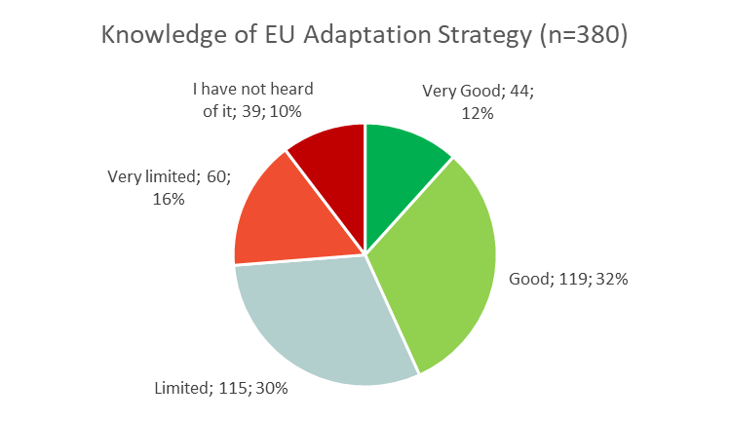

#### Knowledge of local adaptation strategies or action plans by area

Respondents were asked about their knowledge of local adaptation strategies or action plans by area (see Figure 1‑6). Respondents had the possibility to select multiple answers if they knew the adaptation strategy or action plan of multiple areas. Out of the 386 stakeholders, 280 responded and had knowledge of at least one strategy or action plan. The most predominant strategy known by stakeholders was by far from their country (known by 84% of respondents), followed by their region (by 44%), and lastly their municipality (by 33%). 51 of the respondents (13% of 386 respondents) knew their countries, region’s and municipality’s strategy.

Figure 1‑6 Respondent knowledge of the adaptation strategy or action plan by their local area (Country, Region, Municipality)[PC10]

#### Knowledge of adaptation action programmes

Respondents were asked about their knowledge of broader climate change adaptation action programmes (see figure 1.7). Again, they were given the opportunity to select multiple answers and a total of 1187 answers were submitted by 338 respondents. Out of all the stakeholders the most well-known programmes were the UNFCCC and Horizon 2020, with 67% of the stakeholders knowing them respectively. The least well-known programme was the Common Fisheries Policy with only 24% of stakeholders acknowledging their awareness of this programme. Merely 49 (14%) of respondents had heard of none of the adaptation action programmes.

Figure 1‑7 Respondent knowledge of broader adaptation action programmes [PC10]

#### The necessity of EU-level action to adapt to climate change

Most stakeholders (93%) believed that EU-level action is necessary to combat adaptation to climate change (see figure 1.8). Only 5% of those consulted believed EU action is unnecessary and an even smaller 2% did not know their stance. This highlights the perceived importance of the EU Strategy on Adaptation to Climate Change.

Figure 1‑8 Respondents view of whether EU-level action on adaptation to climate change is necessary [PC11]

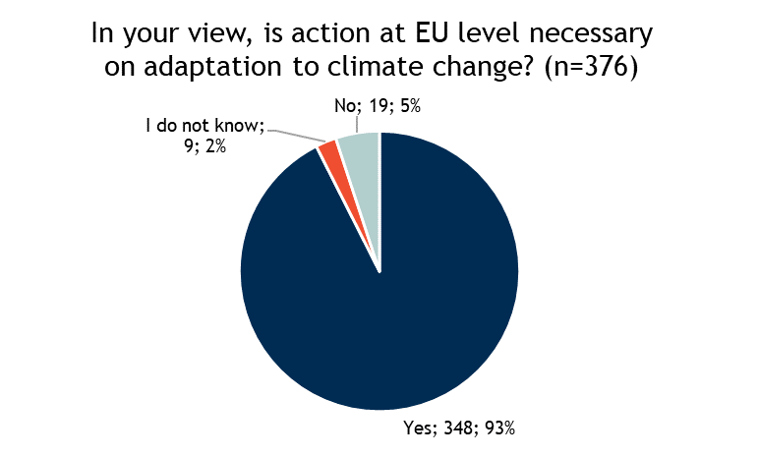

### Part 2: Generic Conclusions

In this section of the public consultation, stakeholders were provided with a table containing 18 generic conclusions about adaptation and asked to select how much they agree with the statements. The options they had to answer were Strongly agree, Agree, Neutral, Disagree, Strongly disagree, Do not know. The results are displayed in Figure 1‑10.

Figure 1‑9 To what extent stakeholders agreed with generic conclusions about adaptation to climate change [PC12]



With only a few exceptions, respondents mostly agreed across the board to the 18 generic conclusions. Strongest agreement was found for the conclusions “Adaptation action is needed at all governance levels”, “There is a need for ensuring that EU policies, investments in infrastructure and insurance and financial products take due account of climate change and respond to its impacts”, and “The EU needs to encourage adaptation action by Member States” were predominantly Strongly Agreed with (78%, 77%, and 68% respectively). Furthermore, the same three conclusions had over 90% of the stakeholders with some form of agreement (Strongly Agree or Agree). This highlights the importance that Stakeholders believe adaptation action holds. They mostly agree that adaptation action should permeate through all governance levels and EU policies and furthermore believe the EU should be encouraging this action.

Only one conclusion stands out regarding stakeholder disagreement. This was “The financial resources for the implementation of the actions described in the Strategy were adequate and proportionate” which 28% of respondents replied neutral, 28% disagreed, and 6% strongly disagreed, and only 13% signalled some form of agreement. This can in part highlight how stakeholders are dissatisfied with current EU adaptation action. The breakdown of respondents to this question was as shown in Table 1‑1, which shows that disagreement was strongest amongst NGOs, more than half of NGO respondents disagreeing or strongly disagreeing, the proportions were lower for other stakeholder types, except EU institutions or bodies, many:

Table 1‑1: Responses by respondent type: To what extent do you agree with [preliminary conclusions]: e) The financial resources for the implementation of the actions described in the Strategy were adequate and proportionate, n=159.

|  |  |  |  |  |  |  |  |
| --- | --- | --- | --- | --- | --- | --- | --- |
| Stakeholder types | Strongly disagree | Disagree | Neutral | Agree | Strongly Agree | Do not know | Total |
| EU institution or body | 0 | 2 | 0 | 1 | 0 | 0 | 3 |
| Regional government/ administration | 1 | 3 | 4 | 2 | 0 | 5 | 15 |
| Private sector (organisation or company) | 3 | 8 | 10 | 3 | 0 | 14 | 38 |
| NGO | 3 | 8 | 6 | 2 | 1 | 1 | 21 |
| International organisation | 1 | 1 | 3 | 0 | 0 | 0 | 5 |
| National government/ administration | 0 | 7 | 5 | 3 | 1 | 4 | 20 |
| Private individual | 0 | 0 | 0 | 0 | 0 | 0 | 0 |
| Local authorities | 0 | 4 | 5 | 1 | 1 | 4 | 15 |
| University or research organisation | 0 | 5 | 7 | 4 | 2 | 6 | 24 |
| Other | 2 | 6 | 5 | 0 | 0 | 5 | 18 |
| Total | 10 | 44 | 45 | 16 | 5 | 39 | 159 |

On the question of whether adaptation and disaster risk reduction policies are inadequately coordinated at national level, there was a significant minority that disagreed. National authorities themselves were neutral or tended to agree with the statement, but private sector stakeholders, NGOs and regional authorities were more likely to disagree with the statement.

The conclusion with the most mixed response from stakeholders was “EU adaptation action is not aligned with international obligations and expectations under the Paris Agreement”. Which 16% of the respondents agreed with, 30% remained neutral, and 24% disagreed. The most notable split by stakeholders on this was that more than 50% of NGO stakeholders agreed with this statement, whilst only 11% of national government stakeholders did.

### Part 3: Specific and Technical Conclusions

Similarly, to the question on the general conclusions, stakeholders were provided with a table that had 20 specific and technical conclusions that related to the study that supported the evaluation of the EU’s Strategy on Adaptation to climate change. These conclusions were segmented into 5 sections: Relevance, Effectiveness, Efficiency, Coherence, and EU added value. For all the conclusions the respondents were able to reply with Strongly Agree, Agree, Neutral, Disagree, Strongly Disagree or Do not know.

#### Relevance

Relevance was aimed at seeing if the Strategy responded to real needs and to all the needs. It further questioned if the needs have evolved. This section contained the technical conclusions: a) The Strategy is relevant for local government and private sector stakeholders; b) Knowledge gaps remain and new gaps are emerging. There remains a need to bridge these gaps and improve how this information is shared; c) There is a need to address the impact of high-end climate change (>2°C); and d) There is a need to align EU adaptation policy with international developments like the Paris Agreement. The stakeholders’ responses are shown in Figure 1‑10.

Across the four questions respondents generally answered with Strong Agree or Agree, particularly for b), c) and d), where both answers make up over 80% of total responses. The most disagreement was registered for the relevance of the strategy for local government and private sector stakeholders. This shows an interesting contrast to [PC12] (see top row of Figure 1‑9) where respondents nearly exclusively strongly agreed that adaptation action was necessary for all levels of governance, perhaps signalling that the disagreement was focused on the private sector element. However, overall it was still a relatively small minority of stakeholders (14%) that disagreed that the Strategy is relevant for local government and private sector stakeholders.

Figure 1‑10 Specific and technical conclusions: Relevance [PC13]

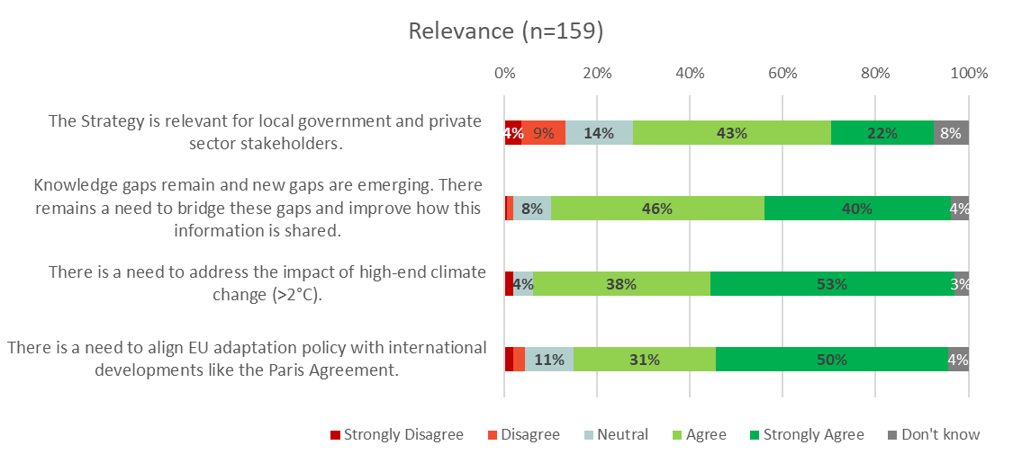

#### Effectiveness

Effectiveness was focused on whether the Strategy achieved its objectives. This was covered by the conclusions: a) The ex-ante conditionality on adaptation for accessing EU funding (ESIF programmes) has been an effective mechanism for ensuring the adoption of national adaptation strategies; b) Climate change adaptation has been effectively mainstreamed in EU spending; and c) The Strategy has been more effective in encouraging preparatory adaptation activities, than in encouraging the implementation and review of such activities. The stakeholders’ responses to these are displayed below in Figure 1‑11.

The responses to these conclusions were more varied than for relevance, with less certainty from respondents also being reflected in the higher number of ‘don’t know’ answers. Yet the first two questions highlight respondents assessing the Strategy as somewhat ineffective, agreeing with the conclusion that the Strategy has been more effective in encouraging preparatory actions than implementation, and a majority of those with an opinion disagreeing that climate adaptation has been effectively mainstreamed in EU spending. Respondents were very evenly split on whether ex-ante conditionalities have been effective.

In terms of stakeholder type there was some significant variation in response in respect of the effectiveness of climate mainstreaming with both regional (33%) and national authorities (45%) being much more positive than the overall average (21%) about mainstreaming effectiveness.

Figure 1‑11 Specific and technical conclusions: Effectiveness [PC13]

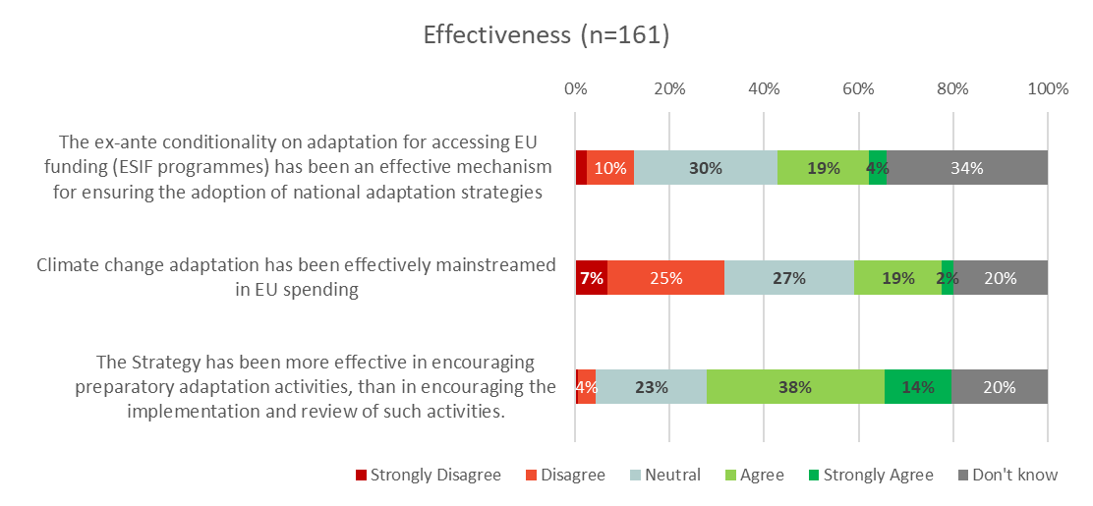

#### Efficiency

Efficiency targeted whether resources were adequate and proportionate to achieve objectives of the Strategy. The conclusions presented here were: a) Administrative costs resulting from the direct implementation of the Strategy are very low and mostly limited to the European Commission; b) Costs resulting from the Strategy for stakeholders other than the European Commission are voluntary and mostly incurred when applying for EU funds; c) There is only very limited monitoring and evaluation burden from the Strategy and no unnecessary administrative burden. The respondents’ answers to these are presented in Figure 1‑12 and show that over 1/3 of respondents didn’t know and a further 25-30% were neutral. This highlights the difficulty of these questions to answer.

The responses that did express an opinion generally agreed with each of the statements that costs and burdens from the strategy are low.

Figure 1‑12 Specific and technical conclusions: Efficiency [PC13]

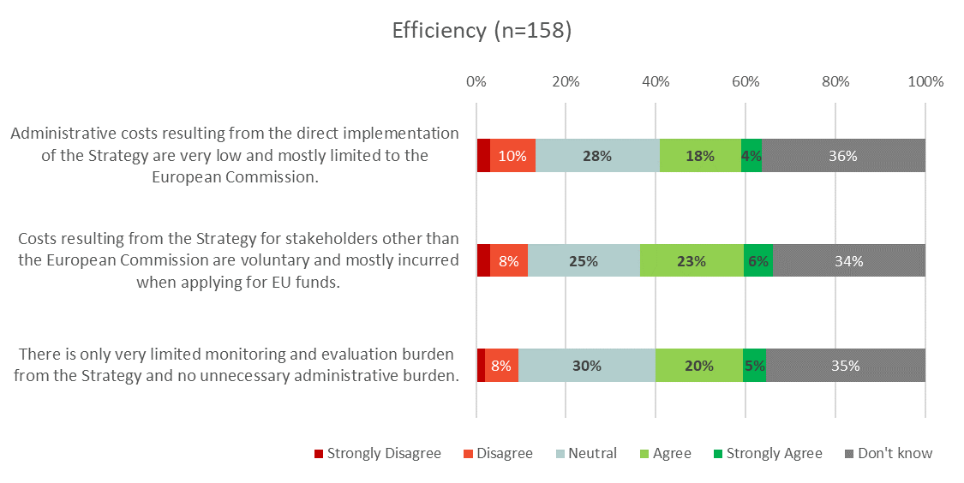

#### Coherence

Coherence focused on whether the Strategy was aligned and coherent internally and with other policies. Conclusions in this section included: a) Progress has been made in integrating adaptation concerns into a wide range of EU policy areas; b) Adaptation concerns are insufficiently integrated in: i) the EU's external policy areas, and ii) climate mitigation policy; and c) The Strategy does not conflict with adaptation action at: i) international level, ii) national level, and iii) sub-national level. The responses from the stakeholders are illustrated in Figure 1‑13.

Overall, respondents replied positively across the board to these conclusions, mostly agreeing and (to a lesser extent) strongly agreeing. The agreement with conclusions that whilst progress has been made in integrating adaptation concerns into EU policy that this is still insufficient in many areas. Specifically, a significant proportion of the respondents were more confident that adaptation concerns are insufficiently integrated in climate mitigation policy (50% agree or strongly agree), compared to EU external policy areas (where 44% agreed or strongly agreed). In respect of the Strategy not conflicting with action in other areas or at other levels the respondents strongly agreed.

The largest disagreement with these statements was found for the propositions that ‘progress has been made in integrating adaptation concerns into a wide range of EU policy areas’ (16% disagreeing), and for ‘adaptation concerns are insufficiently integrated in: climate mitigation policy’ (11%). In the former case it was particularly NGOs (31% disagreeing) and Private sector (28%) stakeholders holding this view, whilst national, regional and local authorities were much more likely to agree (all >66%) with the statement. For the latter question on insufficient integration in climate mitigation policy a very similar picture could be found with regional government (27%) and NGO (27%) stakeholders much more likely than average (15%) to disagree with the statement, whilst national and local authorities much more likely to agree with the statement.

Figure 1‑13 Specific and technical conclusions: Coherence [PC13]

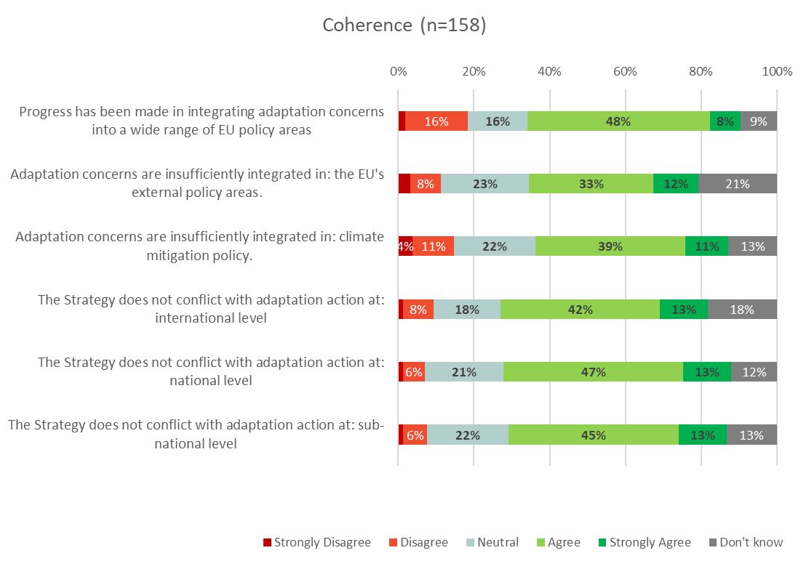

#### EU added value

The added value of the EU aimed at seeing if respondents thought the Strategy had added value at the EU level compared to lower levels of governance. This section had the following conclusions: a) The Strategy adds value to the adaptation actions at national and sub-national level; and b) The greatest added value of EU action is: i) where the EU can integrate adaptation into its own policies, ii) bridging knowledge gaps, and iii) promoting EU-wide action.

The respondents almost exclusively agreed with the conclusions about EU added-value to some level. This highlights that many believe in the importance of the Strategy and EU action for adaptation to climate action. Furthermore, most stakeholders more strongly agreed that the greatest value of EU action is through mainstreaming adaptation into its own policies.

Figure 1‑14 Specific and technical conclusions: EU added value [PC13]

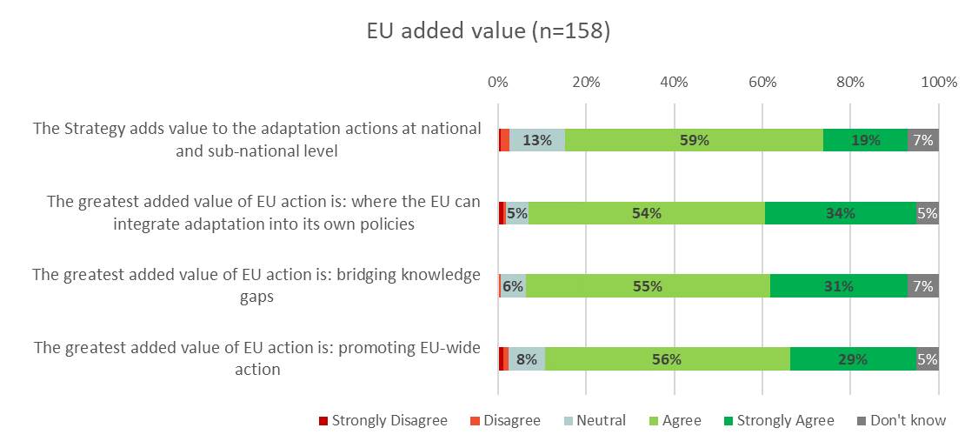

### Part 4: Open Questions

This section provided the respondents the chance to add any further comments they may have about the EU’s Strategy on adaptation [PC14]. Out of the 386 stakeholders involved in this public consultation, 239 submitted an answer to this open question. These comments have been analysed and sometimes shortened to fit them into the report. In addition to the open question, stakeholders had the opportunity to provide any documents they felt were relevant to the evaluation.

#### Further questions and documents to the public consultation

Stakeholders seemed to generally favour adaptation actions, however there was a further focus on mitigation action by some. In addition, many stakeholders referred to the effectiveness of local, national and supranational (EU-level) governance of adaptation action. A further focus was placed on specific policy sectors. Lastly a large body of the respondents felt that there should be greater awareness of adaptation and climate change issues.

**Links to climate mitigation**

The mention of mitigation issues was frequent in this section. Some comments were directed specifically and solely towards mitigation. This could suggest more effort is necessary to raise public awareness of the specific nature and importance of adaptation to climate change. However additionally many comments referred to climate change mitigation as being the more important aspect of climate action. This could signify the necessity to increase public awareness of the need for an EU adaptation strategy. It may also suggest that ensuring better coherence of mitigation action with adaptation goals could be one approach to improving outcomes on adaptation, rather than allowing the two outcomes to be seen as in competition.

**Specific country examples**

Many noted that the integration of adaptation concerns into national policies are taking place. Greece was noted by one respondent as heavily integrating and making good progress on a wide variety of EU climate change adaptation policy. France too, were positively noted by another stakeholder for embedding Task Force on Climate-related Financial Disclosures (TCFD) recommendations into financial sector regulations, as with their FR Energy Transition Law, Article 173. However, it was further discussed by a few that many Member States, though incorporating adaptation policy, still lack concrete plans. Additionally, studies into the successes, gaps and possible improvements of national adaptation policy were noted to be lacking. Furthermore, many stakeholders noted their dissatisfaction with adaptation action, stating that is was insufficient.

**Gaps in action by local government**

One such area of dissatisfaction was from the inaction of local government and the private sector, which was noted as being harder to deal with. One respondent noted that their regional government funded the wrong solutions to climate impacts, which caused more problems. They cited the deepening of rivers that were overflowing due to bridge infrastructure and the pruning of trees that were needed for shading in the summer. Some local governmental actions were also noted as being aligned more with profit than environmental concerns, exacerbating climate change effects rather than adapting to them. Portuguese seaside construction and bad management of forest fires were two notable examples. It was suggested by a respondent that local authorities should respect the containment of land consumption (at least where there are planning tools to allow it), to allow for more adaptation. One respondent noted that in Bulgarian cities green spaces are quickly consumed against the wishes of some of the local populace. This was again attributed to governments putting economic concerns ahead of environmental ones. Lastly many of the stakeholders stated that a local level of action was one of the most pivotal as local inaction hinders the action on a broader scale. Many went further to state that the actions of individuals and our consumption habits need to be altered to truly affect climate change and aid and should be a focus of adaptation strategies. This highlights the importance of individual level action and additionally the level of municipalities.

**A stronger EU role is needed**

Some of the comments further noted that a strengthened role of the EU was required. One stated that MSs should be required to take anticipatory adaptation actions under EU funding programmes up until 2020. It was further noted that the LIFE programme required more public awareness. Several of the stakeholders noted EU-added value being intrinsically linked to its structural funds (such as the EFSI and LIFE programme). Some of which stated that southern countries, or countries that need but aren’t concerning themselves with costly measures really benefit from EU funding assistance. Another highlighted that the adaptation Strategy was useful for filling in gaps of action from MSs policy, however that this didn’t necessarily lead on to effect implementation. Monitoring failures and successes of adaptation action/policy on a supra- and sub-regionally level was mentioned as a useful action to be taken by the EU. Furthermore, it was suggested that the next adaptation strategy should have linkages to the emerging transformative EU financial regulation, such has the High-Level Expert Group (HLEG) on Sustainable Finance. The economic support of the Covenant of Mayors for Climate and Energy initiatives was recommended as a potential forward action. Lastly, it was noted by one stakeholder that external action to encourage non-EU MSs was more important and lacking than internal EU action.

**Better links between public authorities**

Linkages was an important theme amongst many of the respondents. Beyond the necessity for action on all the various levels of governance (local, national, and international), several stakeholders noted that the linkages between these was in some ways more important. Effective cohesion between all three could allow each to present its own full added-value without wasting time on duplicated efforts, or on efforts that level of governance was ineffective at. For example, there are several issues at stake for adaptation action and as one stakeholder noted there is no one size fits all approach. Each region has different needs regarding adaptation. However, as others commented concrete MS plans and actions were also a means of enforcing change. Lastly the EU, as noted, was seen as a positive force of funding action where there was little other drive nationally to do so. In addition, adaptation was noted by some to be an international issue, where third countries outside of Europe effect adaptation issues within the EU’s territory. Therefore, the EU as an international climate change actor was noted as being useful. Furthermore, several noted that linkages between mitigation and adaptation was important to keep coherent throughout EU strategies on climate change. Both are affected and complement one another, so they should be linked more often, according to respondents.

**Economic sectors and adaptation**

Sectoral concerns and recommendations were predominantly for agricultural and green infrastructure policy. However, stakeholders mentioned golf tourism, port industry, forestry, transport, and biodiversity policy, as well. Regarding golf tourism and forestry, stakeholders highlighted the importance for the creation and maintenance of natural green spaces. Both were noted as being crucial parts of the EU’s economy (golfing contributing to EUR 15.1bn. of Europe’s economy). However, climate change threatens to damage the golfing industry, especially the historical coastal golf courses. For biodiversity and it’s use for adaptation action, it was noted that there are several low-cost actions, such as the maintenance of hedgerows, however this often isn’t carried out. Furthermore, they all noted that there needs to be further integration of these sectoral policies into the adaptation Strategy.

**Agriculture and adaptation**

Agriculture was further noted as an area to integrate into adaptation policy. The largest focus was on applying the agroecological model into the agricultural sector. One respondent said that such reform is required in the most radical nature for the Common Agricultural Policy (CAP). According to respondents, the CAP currently promotes the overuse of water, soil degradation, increased flooding, and biodiversity loss. They suggest a focus on transitioning farmers to sustainable farming methods would deliver adaptation efforts better. Allegedly there has been little improvement in climate action spending under CAP (contrary to EC claims). However, another respondent stated that there is a lot of spending on climate adaptation in the farming sector, however studies show that this translates to little actual change in farming practices. They suggest a change from the “box-ticking approach”. Lastly, peatland was recommended by one respondent as a crucial focus for adaptation strategies. Currently the EU policy on adaptation to climate change and the water framework directive do not define peat soils as fields. This makes peat farmers or owners of peatland less able to apply for agricultural subsidies. It was recommended that this should change to promote the use of peatlands for adaptation action.

**Green infrastructure**

Furthermore, green infrastructure was a policy sector that several stakeholders noted as being important for further action. One stakeholder noted that there needs to be more obligations on green infrastructure, and that not enough is being done, even though we know the benefits of such infrastructure. A respondent from Hungary noted how insulation is extremely important there for adaptation (to protect from extreme temperatures and air pollution), and not enough is being done to ensure residential buildings are fitted for livelihood. As previously noted, in Bulgaria, one stakeholder highlighted how green spaces are often removed by local government for economic purposes irrespective of the locals wishes. It was requested that the EU takes a firmer stance against this. Additionally, another stakeholder suggested that EU legislation should make sustainable infrastructure cheaper to block the maintenance and new building of unsustainable cities.

**Awareness raising**

Lastly, many of the stakeholders clearly expressed their belief that raising awareness was needed. This revolved around several issues, public awareness/education on the climate change and adaptation, better communication on EU adaptation action, and better risk awareness. Firstly, as was noted by one respondent, raising risk awareness is vital as many people aren’t aware of the risks faced by fellow EU citizens if they’ve never faced those specific sever climate events (e.g. droughts in Scandinavia, or flooding in highlands). Secondly several comments were made as to the lack of knowledge the stakeholders had on EU action against adaptation. Lastly most suggested broadly that the public needs to be more aware of adaptation generally. Some suggested that educational programmes in schools were vital, whereas some suggest that EU-level direct public awareness action was needed at a much greater level than it already is doing.

### Position Papers

In addition to the survey questions, stakeholders were also invited to provide further information in the form of written responses or position papers. The following position papers were received, and a short summary of their key points is provided below. These papers will be considered when preparing the final evaluation report for this work.

* **Oasis Consortium –** Short response to the EU Adaptation Strategy Consultation – March 2018: this short paper focuses on the financial and damage impacts of climate change in the Danube river basin. It highlights how their modelling framework is being used by the insurance sector and how more generally Action 8 of the strategy would benefit from better links between academia and science and end users of such information, with standardisation and data sharing crucial to this.
* **Expert Working Group on Climate Change and Territorial Development** - Input to Consultation Process of EU Adaptation Strategy Evaluation: identified areas where the Strategy needs to strengthened including: (1) Interconnection of the adaptation, mitigation and resilience issues; (2) Incorporating climate change issues into regional and local plans; (3) Best practices for a territorial approach include – addressing gaps in effectiveness, mainstreaming ecosystem-based adaptation, ensuring greater coherence between national and city levels and mitigation and adaptation; and (4) to better recognise the territorial approach at EU level.
* **Insurance Europe** – Response to the EC’s consultation on the evaluation of the EU’s Strategy on adaptation to climate change: this response highlighted the important role of insurance as an investor and emphasised that more needs to done by policymakers to adapt the regulatory framework to be more sensitive to insurers risk profiles. The paper presented a position of the role of the insurance sector in adaptation from risk identification, transfer and recovery – but noting that insurance is not a substitute for adaptation measures or an instrument for funding these. In their view, avoiding moral hazard is key to increasing adaptation, a focus on management and prevention, better than post-disaster relief. They strongly recommend the EC to “monitor and support where necessary member states that have repeatedly failed to implement preventive and adaptation measures following a natural disaster. This would enable a more responsible use of the EU Solidarity Fund.” In addition, they note that adaptation requires government action in land use planning, infrastructure, research and other areas – with the former being an area for particular attention and that the EU should ensure this is included in national adaptation strategies. Attention is drawn to the benefits of public-private cooperation, the need to tackle (catastrophe) insurance gaps and that regulatory frameworks (e.g. Solvency II) should be more supportive of the sustainable investor role that the sector also plays.
* **CER (Community of European Railway and Infrastructure companies)** – contribution to the public consultation on the evaluation of the EU’s Strategy on Adaptation to climate change: The CER believes the present framework is sufficient. However more inter-nation collaboration is required. The coherence of mitigation and adaptation is a sure-fire and necessary means of adhering to the Paris Climate Agreement. This is particularly true for transport and infrastructure where the decarbonization of the sector is a must. Finance is the primary challenge for an improved resilience of transport infrastructure. There should be both suitable national and supranational funding for this. They suggest a structural framework within the Strategy to value adaptation, to allow funding to the most vulnerable systems and services.
* **CAN (Climate Action Network)** – CAN Europe paper in submission on the EU adaptation Strategy: This document was submitted by four separate stakeholders. CAN understands the necessity for a robust instrument to guarantee the implementation of ambitious and effective adaptation plans. They state their belief that this should be a legally-binding instrument, requiring Member States to update their National Adaptation Plans (NAPs) relatively regularly (every 3-4 years), and produce multi-stakeholder dialogues to identify challenges of adaptation. Their view is that the EU-added value here is from its ability to identify and address transboundary risks. Furthermore, they note the EU Budget should be a 100% climate proof financial framework, with the integration of all climate action (mitigation and adaptation) for the post-2020 Multiannual Financial Framework (MFF). They believe an increase from 20% to 40% climate-specific support under the next MFF is viable and appropriate.
* **CEMR (Council of European Municipalities and Regions)** - CEMR input to the consultation on the EU Adaptation Strategy Mach 2018 – main messages: they focus their paper on the need for additional (supra)national action in policy and funding to properly mobilise and allow for subnational action. Providing cities and regions the leverage to fight climate change through initiatives such as the Global Covenant of Mayors for Climate and Energy and the UN constituency of Local Governments and Municipal Authorities. They additionally provided comments on climate adaptation from five of their members, who noted a variety of actions which are being undertaken by them in their regions. One of the members was COSLA, who also submitted their statement directly to the consultation request.
* **Climate Alliance –** Implementing Adaptation to Climate Change at the Local Level: Climate Alliance also advocates for stronger support for local and subnational adaptation action, e.g. through the provision of additional funding opportunities and capacity-building, notably via the Covenant of Mayors. In addition, the support and maximisation of synergies of multi-level governance and coherence between the actions of different levels of government on adaptation was viewed as a key for the future of the EU’s adaptation Strategy. The network further noted a possible exploration of fast-tracking the access of funds to local and regional authorities that have developed risk and vulnerability assessments or climate adaptation action plans. Climate Alliance further referred to the European Committee of the Regions’ Opinion: “Towards a new EU climate change adaptation strategy – taking an integrated approach" as well as to a resolution on local adaptation action voted by its 1,700 members, both supporting these points.
* **Codema** – National Adaptation Framework, Response to Consultation: Codemas document outlined their work with the four Dublin Region Local Authorities (DLAs) to achieve a more integrated climate change strategy in their operations and services. Some key areas of concern were that conflicting or absent legislation can hinder the implementation of the DLAs plans. They note that cost-benefit analyses are useful in assessing the economic value of policy, however they note that qualitative assessments are necessary too to evaluate the implications of adaptation policy beyond economic costs (i.e. environmental, social, and human health impacts). Additionally, they also note the need for multi-level governance commitment and ambition, aided through cross-sectoral dialogues and engagement to allow for more creative solutions and for the sharing of best practices.
* **COSLA (Convention of Scottish Local Authorities)** – COSLA believe that local authorities are the forefront of the challenge of adaptation and mitigation and believes the EU should assist with making this level of governance as effective as it can be, in conjunction with multi-level governance solutions. They welcome the Covenant of Mayors as a large influencer of local action supplementary to other local sustainability initiatives such as: the UN Resilient Cities campaign, the UN Sendai Framework, and the European Reference Framework for Sustainable Cities. They note that the Strategy should focus more on influencing this local level to upscale its effectiveness.
* **CPMR (Conference of Peripheral Maritime Regions)** – Review of EU Strategy on Adaptation to Climate Change: The CPMR supports the EU added value that comes from the Strategy. Their paper highlights that the EU (particularly the Commission) should pursue a more ambitious approach to support bottom-up action. A focus on local and regional action is *additionally important as regional governments have a pivotal role to play in co-ordinating and driving forward climate action, providing a focal point for local led actions.* This can be aided through the sharing of best practices between regions to allow for an easy transferal of expertise and easier future implementation of adaptation strategies across the EU. They cite that data access is a crucial factor for the success of the design, implementation, and monitoring of adaptation strategies. Beyond intra-EU multi-governmental cooperation, external cooperation is highlighted as well. The CPMR suggest pushing for cooperation initiatives between EU regions and USA states to effectively deliver the Paris Climate Agreement. Lastly, they support the maintenance and possible extension of financial instruments. They would like to see the much greater priority being given to using the EFSI for key adaptation and mitigation efforts at a regional level. Furthermore, better advice, i.e. through the European Investment Advisory Hub, should be provided to regions wishing to access funds, to the acquisition of funds more accessible.
* **Dr Eoin O’Neill (University College Dublin)** – Submission to Evaluation on EU’s Strategy on Adaptation to Climate Change: Dr O’Neill notes several improvements to the Strategy that he believes should be made. These include a greater focus on the implementation of adaptation action, rather than what he refers to as inconsistent national strategies;the consideration of mobilizing private sector finance, to complement the LIFE funding programme; the need for an urban adaptation funding programme; and a greater focus on bridging the knowledge gap, particularly for public awareness, but also through utilizing a wider body of research carried out by universities and research institutions.
* **ECR (European Committee of the Regions)** – Opinion, towards a new EU climate change adaptation strategy, taking an integrated approach: A large focus for the ECR is on multi-level governance cooperation to encourage better collaboration and better implemented strategies. Initiatives such as the Covenant of Mayors for Climate and Energy, the new EU Urban Agenda Partnerships, and knowledge sharing tools such as Climate-ADAPT, are therefore paramount. The believe the Commission should focus on enabling further cooperation for capacity building in cities and regions. In addition, access to financial instruments is key. Cities and Regions struggle most on getting funding for environmental initiatives, so further national and separations funds must become more easily accessible. Further external action from the Commission to push climate adaptation action further on the international stage is also necessary.
* **ECOS (European Environmental Citizens Organisation for Standardisation)** – Evaluation of the Adaptation to Climate Change Strategy, Reponses to the Commission’s Public Consultation: ECOS support the Strategy, however further wants to see an EU adaptation-specific legislation, to raise the importance of adaptation to climate change; a better coordination of the work of the European Committee for Standardisation (CEN) on climate-resilient infrastructures on the one hand and on buildings’ design on the other as part of Action 7; and to extend the scope of climate-resilient investments, which is missing private sector involvement (other than in Action 8’s private investments related to natural disaster insurances).
* **EPSU (European Public Service Union)** – Letter to Commissioner Miguel Arias Canute, Evaluation of the EU Adaptation Strategy: Jan Willem Goudriaan from EPSU states in this letter his outlook that while mitigation measures remain central insufficient adaptation action has currently been taken. This is the case for insufficient national plans, lack of public investment, and monitoring processes. For him a greater focus needs to be made on consulting with trade unions and the work force to ensure mitigation and adaptation implementation. Social dialogue, he believes, is key for broader support for the Strategy.
* **Euromontana** – Evaluation of the EU’s Strategy on Adaptation to Climate Change, What future for Europe’s mountains?: Euromontana highlights the need to address the specificities of mountainous areas despite the absence of mountain environments from large environmental treaties such as the Paris Agreement. They further wish to pin point areas where the Strategy could better target adaptation in mountain regions, which they argue are amongst the first areas to be affected by climate change. This includes national strategies taking into account mountainous regions; for LIFE funding to focus more on ecosystem services, particularly, as mountains are biodiversity hotspots across the EU; better research and data on the of the impacts of climate change on mountainous regions; the improvement of CAP, Cohesion, Tourism, and Sustainable Transport policy for specific mountain concerns; a focus on improving Information and Communication Technologies (ICT) in mountainous areas to decrease their carbon footprint and making it possible to collect information on climate change from the region; and better risk management for such areas.
* **Dr Angel Angelidis** - ÉVALUATION DE LA STRATÉGIE DE L’UE RELATIVE À L’ADAPTATION AU CHANGEMENT CLIMATIQUE: Dr Angelidis focuses on the absence of forests and forestry policy from the EU’s Strategy. Climate change is a large challenge faced by European forests, which will have a wide range of effects on them. The EU’s policy on it are dispersed and lacking which means there is no substantial forest fire protection instruments. He suggests the creation of a EU forestry policy, which would allow Commission to implement forestry actions.
* **FERMA (The Federation of European Risk Management Associations)** – FERMA focuses their recommendations on addressing the needs of businesses from a risk management perspective. They suggest: organising EU-wide public access to climate-related risk data; promoting professional risk management practice inside businesses and public entities; and facilitating companies in making use of the available options for financing risks related to climate change. They note the EU as the right level to reduce costs of climate change for businesses and to secure future economic growth, however a future EU strategy on adaptation to climate change still needs to address corporate risk and insurance management. In that respect, FERMA suggests that the Commission promotes a structured risk management methodology to be applied within EU organisations.
* **PLACARD (PLAtform for CLimate Adaptation and Risk ReDuction), ERA4CS (European Research Area for Climate Services), and C3S (Copernicus Climate Change Service)** – Enhance connections between the EU Climate Adaptation Strategy and Disaster Risk Reduction mechanisms: the H2020 project PLACARD, the JPI Climate ERANET ERA4CS, and the Copernicus Climate Change Service C3S believe that a closer connection between climate change adaptation (CCA) and disaster risk reduction (DRR) is required. In their view improved communication, collaboration, data and knowledge sharing, integrated capacity development and funding, and coherence between the two is necessary for actors on all levels of governance.
* **SIM4NEXUS** – EU Climate change adaptation coherent with most other objects of EU policies for water, land, energy, food, and climate: SIM4NEXUS note that there is much room for synergy in with the Strategy and other WLEFC (water, land, energy, food, and climate) policies. Such examples include extending forested areas also creates opportunities to harvest biomass and mitigate greenhouse gases, and by taking adaptation measures against drought, more water is available for hydropower during dry spells.
* **DCCAE (Department of Communications, Climate Action & Environment, Ireland)** – Letter: the DCCAE highlight the importance, yet country specific nature, of adaptation strategies. They note that it is not as easily quantifiable as mitigation, as measures span over long time horizons. They see the closing of existing knowledge gaps and the interlinking of adaptation and mitigation as important next steps. Furthermore, they cite that a coherence between DRR and CCA is necessary to build resilience and increase accessibility of funding.
* **Ihobe** – Revision de la estrategia de adaptatcion al cambio climatico de la ue: Ihobe notes that the Basque Country has implemented the resilience of Basque territory into its 2050 climate change strategy. It has since acted to achieve this goal. They view the EU adaptation Strategy as a good means for others to deal with climate change resilience. However, they believe that a greater focus on multi-level and inter-regional governance is required. They view funding as a major barrier to adaptation action for local governments. Therefore, in light of this, they view EU funds for local actors essential. Lastly, they view the lack of monitoring, reporting, evaluation and knowledge exchange as key weaknesses of adaptation policy and action. According to them, this should be reviewed to reduce knowledge gaps and improve capacity for adaptation action.
* **Life IP C2C CC (Coast to Coast Climate Challenge)** – Consultation on EU Adaptation Strategy: C2C CC believe that although national adaptation is important, regional and local strategies are more important as the point of departure for coordination and co-creation in a multi-level governance system. LIFE funding is viewed as an excellent instrument; however, they suggest an extension or similar instrument as EIB’s ELENA is suggested for adaptation to aid with technical assistance for investments, as well as enhanced possibilities to use Interreg A, B, and C create cross-border projects at all levels. They suggest that, though being useful, Climate-ADAPT is complicated for finding information and would be enhanced by more workshops, face-to-face meetings, and transfers of best practices.
* **NOTA Natuurpunt** – Subject, Evaluation of the EU’s Strategy on Adaptation to Climate Change: Their suggestions for an improved Strategy include a radically reformed CAP, a focus of knowledge on ecological impacts of climate change, the response of the Natura2000 network on a biogeographical (rather than national) basis, a focus on nature-based solutions to adaptations, and a stronger implementation of the Water Framework Directive with links to adaptation. In addition to these comments NOTA Natuurpunt attached a copy of the CAN document, mentioned above.
* **SALAR (Swedish Association of Local Authorities and Regions)** – SALAR view a more integrated approach, linking adaptation and mitigation, as a key step to tackling adaptation. Furthermore, although they view local and regional authorities as the pivotal actor, they state that the national level should not be neglected and in fact should become more ambitious. An inclusion of all relevant stakeholders is also highlighted as necessary, and they provide the example of the Kilmatsamverkan Skåne as positive cooperative approach with all relevant stakeholders at a municipal, regional, county, and insurance company level. They lastly ask for clarity on pre- and post-2020 financing opportunities and making the access of information easier for local and regional authorities.
* **Italian Institute of Health, Department Environment and Health** – Position Paper on the EU’s Strategy on Adaptation to Climate Changes: They highlight Italy as an area that has undergone several severe events that are attributed to climate change, and therefore support the Strategy. They note the need for multi-levels of governance, better research, coordination of adaptation policies, having an ecosystem-based approach (i.e. green infrastructure), having early warning systems, and a better coherence with health and environment and for EU monitoring and national environmental protection laws.
* **Gabriel Franz** – Untitled: Gabriel comments on the adaptation preparedness scoreboard (particularly focusing on Germany) and her view that it is inaccurate. Allegedly Germany appears to have come far with adaptation measures on this scoreboard, however in her experience this isn’t the case. She notes in her state of Hessen, on a municipal level, almost no adaptation actions are present. She wishes for support programmes to help combat climate change (such as with the greening of garage roofs) and demands also that climate protection measures be formulated in the State Development Plan Hesse generally as binding goals and not as non-binding principles.
* **JASPERS (Joint Assistance to Support Projects in European Regions)** – JASPERS comments to the review of the EU adaptation strategy: JASPERS generally agrees with the summary of the EU adaptation Strategy. Among other recommendations, they note some of the largest knowledge gaps being those of research projects (complementary but often side-lined to scientific knowledge gaps). Additionally, there needs to be more practical experience of adaptation action, and the sharing of best practices. A further focus on non-Member State specific entities need to be included in the sharing of such practices.

In addition to position papers and direct responses to the consultation several further documents were shared for consideration by the evaluation team, including:

* DVGW (2009) Climate change and water supply: The consequences of climate change and potential adaptation strategies.
* E3G (2017) Climate Risk and the EU Budget: Investing in Resilience.
* IMPREX (2018) A new dimension in EU’s Climate Adaptation Policy, Eu’s vulnerability to climate change impacts outside its borders.
* Dr Herve Douville (2017) Proposition de Sujet de thèse 2017: Compréhension, hiérarchisation et réduction des incertitudes sur la réponse des moyennes latitudes à un accroissement du CO2 atmosphérique.

**HOW TO OBTAIN EU PUBLICATIONS**

**Free publications:**

• one copy:  
via EU Bookshop (http://bookshop.europa.eu);

• more than one copy or posters/maps:  
from the European Union’s representations (http://ec.europa.eu/represent_en.htm);   
from the delegations in non-EU countries (http://eeas.europa.eu/delegations/index_en.htm);   
by contacting the Europe Direct service (http://europa.eu/europedirect/index_en.htm) or calling 00 800 6 7 8 9 10 11 (freephone number from anywhere in the EU) (*).  
  
[(*)](http://europa.eu.int/citizensrights/signpost/about/index_en.htm#note1#note1) The information given is free, as are most calls (though some operators, phone boxes or hotels may charge you).

**Priced publications:**

• via EU Bookshop (http://bookshop.europa.eu).

**Priced subscriptions:**

• via one of the sales agents of the Publications Office of the European Union (http://publications.europa.eu/others/agents/index_en.htm).

[Catalogue number]